**STAT 40001/ STAT 59800 Statistical Computing Fall 2020**

**Lab-2**

1. Create the following vectors using rep function in R:
2. V1= 1 2 3 4 5 1 2 3 4 5 1 2 3 4 5 1 2 3 4 5 1 2 3 4 5

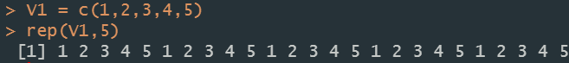

1. V2= 1 1 1 1 2 2 2 2 3 3 3 3 4 4 4 4 5 5 5 5 6 6 6 6

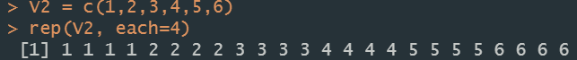

1. V3=5 10 10 15 15 15 20 20 20 20 25 25 25 25 25

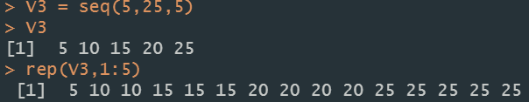

1. V4= Math, Math, CS, CS, STAT, STAT, STAT, PHY,PHY,PHY

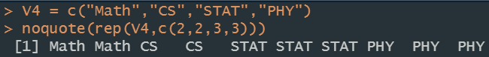

1. Import the data below in R using scan function

2 4 5 6 7 8 9 2 3 4 5 6 77 89 45 67 8 9 0 12

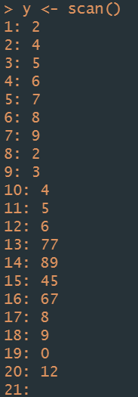

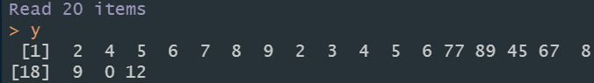

1. Generate the following sequence of numbers
2. 1,2,3,…,50.

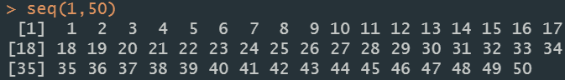

1. 2,4,6,8,…,50

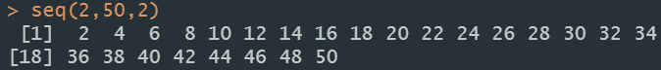

1. "A" "B" "C" "D" "E" "F" "G" "H"



1. e f g h i j k l



1. Suppose we have the data below

2,5,7,8,9,3,5,8,67,45, 1,NA, 34,23,12,90

1. How many observations are there in the data set?



1. Is there any missing value? Use R to check it out.

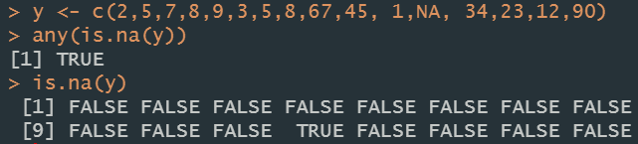

1. Identify the location of the missing value.



1. Identify the smallest and largest observation (both position and the value)

